Update System via SD card

## Applicable products

Pico Goblin, Pico Neo; Pico Goblin 2;

## Update in System Update Application

1. Download PUI system update package ( <https://www.picovr.com/en/puirom.html> ); If Pico support team provided ROM package, then no need to download it;
2. A SD card in FAT32 format (128G in maximum);
3. Create “dload” folder in the SD root catalog;
4. Copy the ROM package to the “dload” folder of the SD card;
5. Insert the SD card into card slot;
6. In "My Applications" → "System Update", click "Offline Update";
7. After detection of the update package, click "Confirm" to update;

Note: Make sure the remaining power of the device is more than 40% during update process; System version update can only be from low to high; Update process takes 3 - 5 minutes.

## Update in recovery mode

1. Download PUI system update package (official download address: <https://www.picovr.com/en/puirom.html> ); If Pico support staff provided the ROM package, then no need to download it;
2. A SD card in FAT32 format (128G in maximum);
3. Copy the ROM package to the SD card root catalog;
4. Insert the SD card into card slot;
5. Make sure the device is power off.
6. Follow the steps below to enter recovery mode:
7. Hold Volume Up button and Power button at the same time.
8. You will see an android robot, which shows “ No commands”; Hold power button and click Volume Up button for once to enter menu interface, as shown below:
9. Use “Volume Up” and “Volume down” buttons to move up and down, and “Power” button to select.

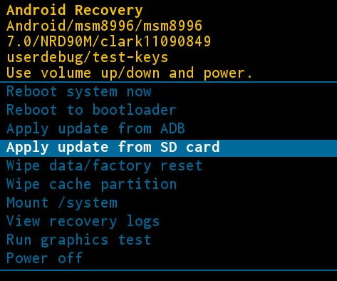

1. Select “Apply update from SD card”.
2. Select the ROM package copied from SD card to install (shown as the picture below). The installation will take 3-5 minutes; Do not press any buttons during the installation.

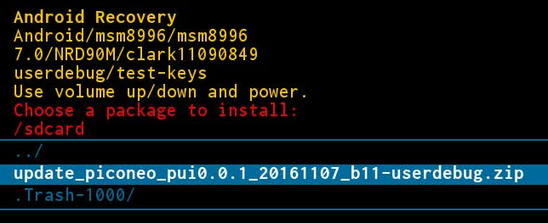

1. After the completion of installation, system will enter menu interface. Select “Wipe data/factory reset to” to erase original data.
2. After back to the menu interface, select “Reboot system now” or “Power off”.
3. PUI update complete

Note: Make sure the remaining power of the device is more than 40% during update process; System version update can only be from low to high; Update process takes 3 - 5 minutes.